Data Structures & Algorithms — Condensed Notes

A. Arrays

Definition
A linear data structure holding elements of the same type in contiguous memory. Each element is accessed by an index, usually starting at 0.

Characteristics
- Contiguous storage: element i sits at a + b(i − s), where a is the start address, b the element size, s the starting index.
- Homogeneous: all elements share the same type and size.
- Fixed size: set at allocation, not easily changed.
- Random access: any element reached in O(1) given its index.

Advantages
- O(1) access.
- Space efficient: no pointer overhead.
- Cache-friendly: contiguous layout improves locality.

Limitations
- Costly resize: growing requires a new array and a full copy.
- Costly insert/delete: shifting elements (except at the end).
- Wasted memory: unused reserved slots stay locked.

Operations & Complexity
Operation | Description | Time
Access | Read element by index | O(1)
Update | Write element by index | O(1)
Traversal | Visit every element | O(n)
Insertion | Insert + shift right | O(n)
Deletion | Remove + shift left | O(n)
Linear Search | Scan for a value | O(n)
Binary Search | Halve range each step (sorted only) | O(log n)

Applications
- Tabular data and records.
- Matrices, grids, numerical simulation.
- Base structure for stacks, queues, heaps, hash tables.
- Image storage as 2D pixel arrays.
- Polynomial coefficient storage.

B. Stacks

Definition & LIFO
A stack restricts insertion and deletion to one end, the top — Last-In, First-Out (LIFO), like a pile of plates.

Operations
Usually array- or linked-list-based; top tracks the last inserted index.
PUSH(S, x)
1. If S.top == S.size: error "overflow"
2. Else: S.top++; S[S.top] = x
POP(S)
1. If empty: error "underflow"
2. Else: S.top--; return S[S.top+1]
PEEK(S)
1. If empty: error "underflow"
2. Else: return S[S.top]

Complexity
- PUSH / POP / PEEK / IsEmpty: O(1) each (amortized O(1) even for dynamic-array resizing).
- Space: O(n) — data storage plus O(1) per stacked recursive call, e.g. O(n) for recursion depth n.

C. Queues

Definition & FIFO
A queue inserts at the rear and removes from the front — First-In, First-Out (FIFO), like a waiting line.

Array-based Implementation
- Front: index of the element to remove next.
- Rear: index where the next element will be inserted.
A circular array lets front/rear wrap to reuse freed space.
ENQUEUE(Q, x)
1. Q[Q.tail] = x
2. if Q.tail == Q.size: Q.tail = 1
3. else: Q.tail++
DEQUEUE(Q)
1. x = Q[Q.head]
2. if Q.head == Q.size: Q.head = 1
3. else: Q.head++
4. return x

Complexity
- ENQUEUE / DEQUEUE / Peek / IsEmpty: O(1) each — pure indexing, no shifting.
- Space: O(n), pre-allocated in a static array.

Applications
- Scheduling shared resources (printer, disk, CPU).
- Breadth-First Search traversal.
- Buffering streamed data in arrival order.

D. Circular Queues
A circular queue links the array's last position back to the first, avoiding the "false overflow" of a linear queue, where freed front slots can't be reused.

Representation
- Front: index of the element to remove.
- Rear: index for the next insertion.
Wrap-around uses the modulo operator: index = (index + 1) % SIZE.

Algorithms
ENQUEUE:
1. If full ((FRONT==0 && REAR==MAX-1) || FRONT==REAR+1): "Queue Full"
2. If FRONT==-1: FRONT=REAR=0
3. Else: REAR=(REAR+1)%SIZE
4. Q[REAR]=DATA
DEQUEUE:
1. If FRONT==-1: "Queue Empty"
2. DATA=Q[FRONT]
3. If FRONT==REAR: FRONT=REAR=-1
4. Else: FRONT=(FRONT+1)%SIZE
5. return DATA

Example (size 5)
With front=2, rear=4 holding elements at 2,3,4, the queue isn't full — enqueuing wraps rear to 0, filling the vacant slot.

Advantages / Disadvantages
- Advantages: efficient memory reuse; predictable O(1) performance without shifting.
- Disadvantages: still fixed size; overflow/underflow logic is more intricate than a linear queue.

Complexity
- Enqueue / Dequeue: O(1).
- Space: O(n).

Exam points
- Overflow: (rear + 1) % SIZE == front.
- Underflow: front == −1.
- Capacity: a size-n circular queue often stores only n−1 elements, keeping one slot free to distinguish full from empty.

Linear Queue vs Circular Queue
Feature | Linear Queue | Circular Queue
Logic | Straight sequence | Ring — last position links back to the first
Index movement | Front & rear only increase | Indices wrap to 0 at the end
Overflow | REAR == MAX−1, regardless of front space | Only when (REAR+1)%SIZE == FRONT
Memory reuse | Dequeued space is never reused | Freed front space is reused via wrap-around

Why circular is preferred
- No false overflow: a linear queue reports "full" even with vacant front slots; wrap-around fixes this.
- Predictable performance: shifting to fix a linear queue costs O(n); the circular queue keeps O(1) inserts/deletes.
- Resource management: well suited to buffering and scheduling that runs continuously.

E. Overflow & Underflow in a Circular Queue (Worked Example)

Conditions
- Overflow (full): (FRONT==0 && REAR==MAX−1) or FRONT==REAR+1, i.e. (REAR+1)%SIZE == FRONT.
- Underflow (empty): FRONT==REAR==−1 (or FRONT==REAR, depending on convention).

Illustration (size 5)
- Start: f = r = −1 (empty).
- Enqueue 32, 18, 58: front → 0, rear → 2; queue = [32, 18, 58, _, _].
- Wrap-around: continuing to enqueue past index 4 sets rear = (4+1)%5 = 0, reusing a freed slot.
- Dequeue: returns 32, front → 1; if front == rear at dequeue time, both reset to −1 (queue empty).
- Full state: f=0, r=4 — next enqueue fails because (4+1)%5 == 0 == front.

Complexity
- Enqueue / Dequeue: O(1) — direct access and pointer updates.
- Space: O(n).

F. Linked Lists
A linked list is a sequence of nodes linked by pointers rather than physical placement; each node holds data plus a pointer (link) to the next node.

Advantages over Arrays
- Dynamic size: grows/shrinks at runtime.
- Fast insert/delete: O(1) once the position is known, versus O(n) shifting in an array.
- No pre-allocation waste: memory is claimed only as nodes are created.
- Cheap reorganization: moving pointers is cheaper than moving large data records.

Types
- Singly Linked List (SLL): one "next" pointer per node, ending in NULL. Forward traversal only; O(1) head insert/delete, O(n) tail delete. Lowest memory overhead; used for simple stacks/queues.
- Doubly Linked List (DLL): "next" and "prev" pointers. Bi-directional traversal; O(1) insert/delete at both ends. Higher memory overhead; used for browser history, LRU caches, undo/redo.
- Circular Linked List (CLL): last node's next points back to the first. Any node can start a traversal; no NULL checks needed, but careless loops can run forever. Used for round-robin scheduling, stream buffering, Fibonacci heaps.

Comparison
Feature | Singly | Doubly | Circular
Pointers/node | 1 (next) | 2 (next, prev) | 1 or 2
Traversal | Forward only | Forward & backward | Forward (both if doubly circular)
End of list | NULL | NULL | Points back to head
Tail insertion | O(n) | O(1) | O(1) with a kept last-pointer
Typical use | Simple stack/queue | Browser history | Task scheduling / heaps

G. Trees & Binary Trees

Definitions
- Tree: a non-linear, hierarchical structure with one root node; every other node belongs to a disjoint subtree. Equivalently, a connected, acyclic undirected graph.
- Binary Tree: a tree where each node has at most two children, distinguished as left child and right child.

Terminology
- Root: the single node with no parent.
- Parent / Child: a node with successors is a parent; each successor is its child.
- Leaf: a node with no children (degree 0).
- Degree of a node: its number of children; degree of a tree is the max over all nodes.
- Depth: path length from root to the node (root's depth = 0).
- Height: longest path from a node down to a leaf; tree height = height of the root.
- Subtree: a node plus all its descendants, itself a valid tree.

Types of Binary Trees
- Full/Strict: every node has 0 or 2 children.
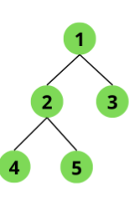
- Complete: every level is full except possibly the last, which fills left to right.
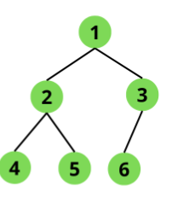
- Perfect: a strict binary tree with all leaves at the same depth.
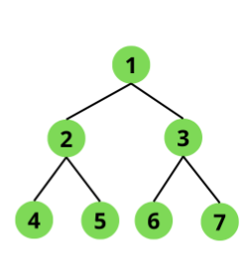
- Binary Search Tree (BST): for every node n, its left subtree holds values ≤ n and its right subtree holds values ≥ n, with no duplicates.
- AVL Tree: self-balancing BST — left/right subtree heights differ by at most one.
- Binary Heap: a complete binary tree satisfying the max- or min-heap property; backs priority queues.

Advantages / Disadvantages
- Advantages: natural for hierarchies; balanced trees give O(log n) search/insert/delete; linked form allocates memory only as needed.
- Disadvantages: more complex to implement than linear structures; balancing (rotations) adds overhead; pointer storage and, for incomplete array-backed trees, unused slots both waste space.

Applications
- File-system directory hierarchies.
- Database indexing (B-Trees, B+ Trees).
- Expression trees for compilers.
- Decision trees for classification/sorting lower bounds.
- Heaps for priority queues and Heapsort.
- Huffman coding for compression.

H. Graphs
A graph G = (V, E) is a non-linear structure of vertices V and edges E connecting vertex pairs — more general than a tree, since any pair of nodes may connect and a node may have multiple incoming edges.
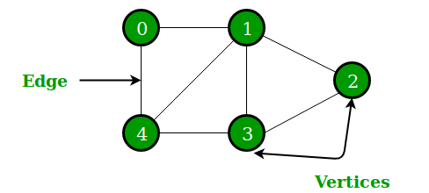

Terminology
- Endpoints: the two vertices an edge connects.
- Adjacent / Incident: two vertices linked by an edge are adjacent; the edge is incident to them.
- Degree: edges touching a vertex (undirected); degree 0 = isolated, degree 1 = pendant.
- Walk / Path: a walk is any vertex-edge sequence; a path repeats no vertex or edge.
- Cycle: a path that returns to its starting vertex.
- Connected: a path exists between every vertex pair.

Types
- Undirected: edges are unordered pairs (symmetric relation) — e.g. a two-way road network.
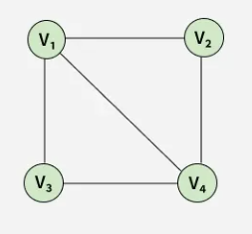
- Directed (Digraph): edges (arcs) are ordered pairs, with indegree/outdegree per vertex — e.g. dependency graphs in dynamic programming.
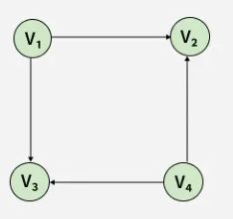
- Weighted: each edge carries a numeric weight (distance, cost, time) — e.g. a road map with distances.
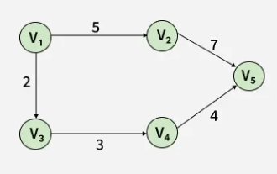
- Unweighted: all edges count equally — e.g. a social network, where "shortest path" means fewest hops.
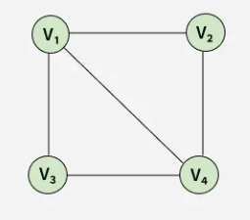

I. Adjacency Matrix vs Adjacency List
Feature | Adjacency Matrix | Adjacency List
Representation | N × N 2-D array | Array of linked lists
Space | O(V²) | O(V + E)
Best for | Dense graphs | Sparse graphs (most real systems)
Edge lookup | O(1) | O(degree(v))
OS example | Theoretical protection matrix | Access-control / capability lists

Adjacency Matrix
Cell [i, j] marks whether an edge exists between nodes i and j. In an OS protection matrix, rows are domains and columns are objects, with each cell holding access rights.
- Advantages: O(1) lookup; conceptually simple, unified view.
- Disadvantages: wastes space on sparse graphs; expensive to resize.

Adjacency List
Stores only the edges that exist, typically via linked lists. OS variants: Access Control Lists (per-object list of domains) and Capability Lists (per-domain list of objects).
- Advantages: space proportional to actual edges; cheap to extend.
- Disadvantages: checking a specific relationship can require an O(n) scan of a list.

J. Divide and Conquer, and Greedy Algorithms

Divide and Conquer
A recursive design strategy with three steps at each level:
- Divide: split the problem into smaller subproblems of the same kind.
- Conquer: solve subproblems recursively, directly at the base case.
- Combine: merge subproblem solutions into the overall answer.
Example: Merge Sort splits, recursively sorts, then merges; Quick Sort does most of the work while partitioning and needs little combining; Binary Search is another classic case.

Greedy Algorithms
A greedy algorithm builds a solution stepwise, always taking the locally optimal choice in the hope it leads to a globally optimal result, without revisiting past decisions.

Steps
- 1. Initialize: start with the problem's initial state and an empty solution.
- 2. Select: evaluate the options available from the current state.
- 3. Check feasibility: pick the best option by the objective function; keep it only if it doesn't violate constraints.
- 4. Augment: add the chosen item to the solution and advance the state.
- 5. Terminate: repeat until solved or no choices remain.

When it's optimal
- Greedy-choice property: local optimal choices lead to a global optimum.
- Optimal substructure: an optimal solution contains optimal solutions to its subproblems.
Greedy fails on some problems (e.g. 0-1 Knapsack, which needs dynamic programming) but succeeds for Dijkstra's shortest path, Kruskal's minimum spanning tree, and Huffman coding.

K. Backtracking and the N-Queens Problem

Definition
Backtracking builds a solution one component at a time, testing each partial solution with a bounding function. A path that can't succeed is abandoned — pruned — and the algorithm backtracks to try another alternative. It is essentially brute force refined via recursion over a state-space tree.

N-Queens via Backtracking
Place n queens on an n×n board so no two share a row, column, or diagonal.
- Representation: an n-tuple (x1,...,xn), where xi is the column of the queen on row i.
- Build incrementally: place queens row by row.
- Check constraints: for each row, try each column and test safety.
- Recurse or backtrack: advance on a safe placement; otherwise return to the previous row and try another column.

Algorithm
nQueens(k, n):
1. For col[k] = 1 to n:
2. If positionOK(k):
3. If k == n: print col[1..n]
4. Else: nQueens(k+1, n)
positionOK(k):
1. For i = 1 to k-1:
2. If col[k]==col[i] or |col[k]-col[i]| == k-i: return false
3. Return true

Worked Example (4-Queens)
- 1. Place Queen 1 at (Row 1, Col 1).
- 2. Queen 2: columns 1–2 are attacked; place at (Row 2, Col 3).
- 3. Row 3: every column is attacked — backtrack.
- 4. Move Queen 2 to (Row 2, Col 4); now Queen 3 fits at (Row 3, Col 2).
- 5. Row 4: every column attacked — backtrack all the way to Row 1; move Queen 1 to (Row 1, Col 2).
- 6. Continue until a valid tuple, e.g. (2, 4, 1, 3), is found.
Positions that fail the bounding function are "dead nodes" and are pruned so their children are never generated.

Complexity
- Time: brute force is O(n^n); backtracking's unique-column constraint reduces the search space to O(n!) permutations, though worst case remains exponential.
- Space: O(n) for the recursion stack and the position array.

